Whistle Blowing and Telling Secrets
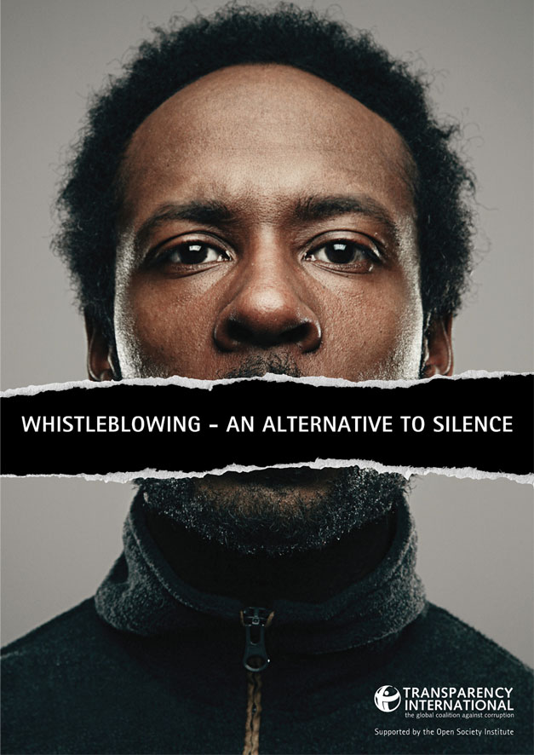
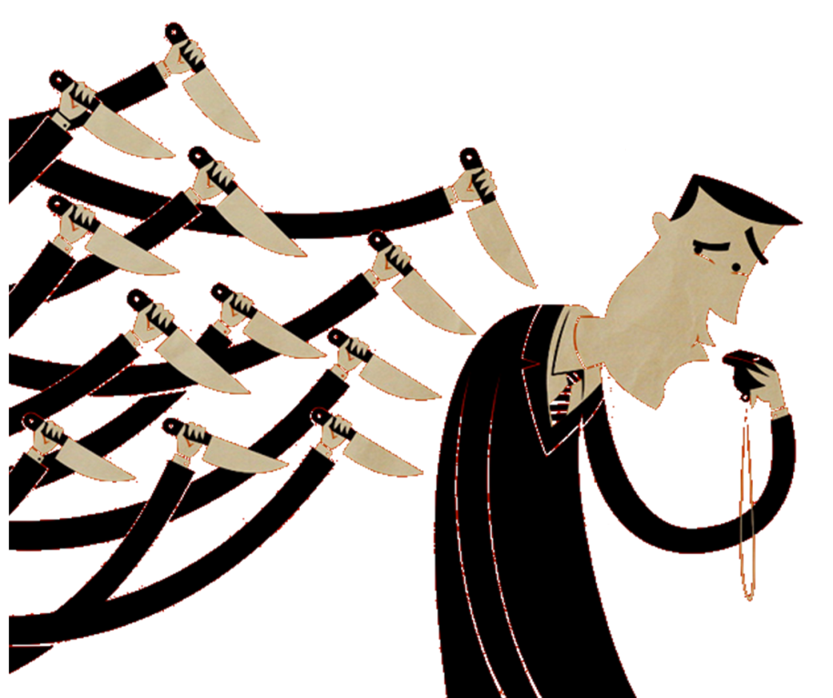
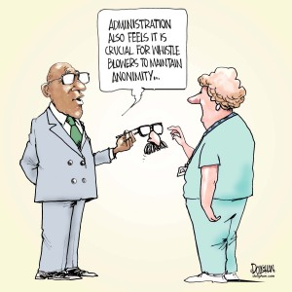
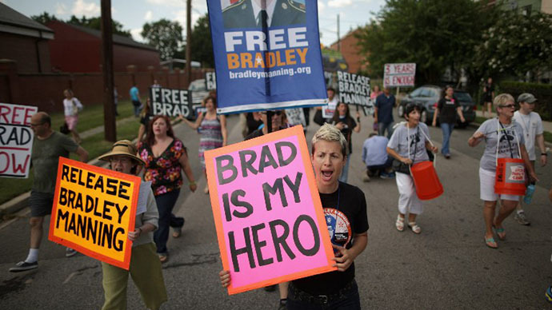
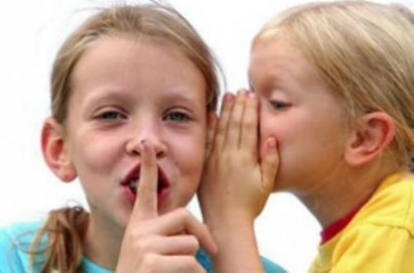
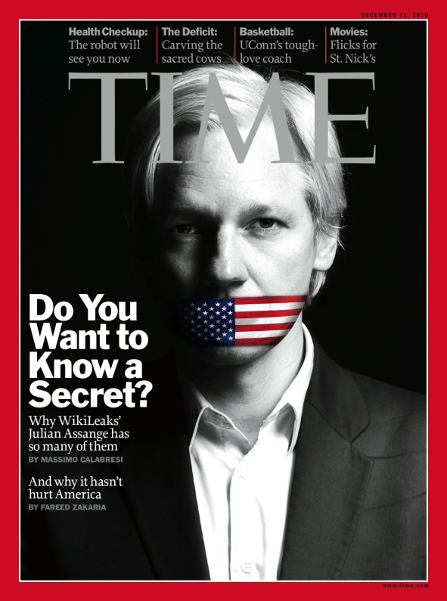
ADMINISTRATION ALSO FEELS IT IS CRUCIAL FOR WHISTLE BLOWERS TO MAINTAIN ANONIMITY. . .
"We say in this nation that we are looking for people with honesty, integrity, drive and dedication, and then when we find such people, we take them out and whip them." Anonymous

"The world is a dangerous place, not because of those who do evil, but because of those who look on and do nothing." Albert Einstein

“He was not a humanist, he was a hacker. He was not a whistleblower, he was a traitor.” Maj Ashden Fein at the trial of Bradley Manning.

"If Bradley Manning did as he is accused, he is a hero and invaluable to all of us. ... It was WikiLeaks’ revelations — not the actions of President Obama — that forced the US administration out of the Iraq War… By exposing the killing of Iraqi children, WikiLeaks directly motivated the Iraqi government to strip the US military of legal immunity, which in turn forced the US withdrawal.” Julian Assange on Bradley Manning during a December address from London’s Ecuadorian Embassy.

“All tyranny needs to gain a foothold is for people of good conscience to remain silent.” Thomas Jefferson

“A nation that is afraid to let its people judge the truth and falsehood in an open market is a nation that is afraid of its people.” John F. Kennedy
___________________________________________________________________________Scenario 1
Sarah confided in her best friend Rebecca that she has been dating the guy of her dreams. “What’s his name?” Rebecca asked eagerly. With a hesitation and a nervous smile Sarah answered.

“Do you remember that guy Revuen? We met him last year when we went to the Grodzinsky’s for Friday night. I thought he was really funny and very intelligent. Well, after getting his number from Rabbi Grodzinsky, we started to date. Things have gone really well. He’s such a sweet and gentle guy. One time we were driving and this motorcyclist banged on the car window as he drove past shouting terrible things at Reuven. He didn’t reat at all! He just dealt with it so calmly. We haven’t told anyone else yet, but he proposed to me last night and I said yes!”

Rebecca was taken aback. She hadn’t told Sarah that she knew Reuven from her home town. In fact, she knew a lot about Reuven. Three years ago he had been arrested for assaulting his girlfriend after an argument. He was charged but got off lightly (in her opinion) with a fine. The poor girl had needed stitches and was very shaken.

“Wow Rebecca,” Sarah said, forcing a smile. “Mazel Tov!”

What should Sarah do?
"We say in this nation that we are looking for people with honesty, integrity, drive and dedication, and then when we find such people, we take them out and whip them." Anonymous

"The world is a dangerous place, not because of those who do evil, but because of those who look on and do nothing." Albert Einstein

“He was not a humanist, he was a hacker. He was not a whistleblower, he was a traitor.” Maj Ashden Fein at the trial of Bradley Manning.

"If Bradley Manning did as he is accused, he is a hero and invaluable to all of us. ... It was WikiLeaks’ revelations — not the actions of President Obama — that forced the US administration out of the Iraq War… By exposing the killing of Iraqi children, WikiLeaks directly motivated the Iraqi government to strip the US military of legal immunity, which in turn forced the US withdrawal.” Julian Assange on Bradley Manning during a December address from London’s Ecuadorian Embassy.

“All tyranny needs to gain a foothold is for people of good conscience to remain silent.” Thomas Jefferson

“A nation that is afraid to let its people judge the truth and falsehood in an open market is a nation that is afraid of its people.” John F. Kennedy
___________________________________________________________________________Scenario 2
Dr. Kaplinsky was walking to his surgery when a young man driving a new Audi stopped just before the Zebra crossing. As Dr. Kaplinsky turned to thank the driver, he noticed that the young man was none other than Yehudah Spitzer, the young 18 year old he had known and treated all his life.

“How much is the insurance on that thing?” Doctor Kaplinsky joked. Yehudah just smiled back and after the doctor had crossed, sped off up the road.

As Dr. Spitzer turned into the surgery a thought struck him. How can Yehudah Spitzer be driving? As an epileptic, he would have to inform the DVLA about his condition and they would contact the surgery for details. If he’s already driving he can’t have done that. Not only that, it would probably invalidate his insurance, if he has any!

Dr. Kaplinsky stopped and thought about the oath he took to protect patient confidentiality. “If I tell the DVLA, the family will never speak to me again.” He said to himself. “They’ll tell the whole community and my reputation will be mud!”

What should Dr. Kaplinsky do?
"We say in this nation that we are looking for people with honesty, integrity, drive and dedication, and then when we find such people, we take them out and whip them." Anonymous

"The world is a dangerous place, not because of those who do evil, but because of those who look on and do nothing." Albert Einstein

“He was not a humanist, he was a hacker. He was not a whistleblower, he was a traitor.” Maj Ashden Fein at the trial of Bradley Manning.

"If Bradley Manning did as he is accused, he is a hero and invaluable to all of us. ... It was WikiLeaks’ revelations — not the actions of President Obama — that forced the US administration out of the Iraq War… By exposing the killing of Iraqi children, WikiLeaks directly motivated the Iraqi government to strip the US military of legal immunity, which in turn forced the US withdrawal.” Julian Assange on Bradley Manning during a December address from London’s Ecuadorian Embassy.

“All tyranny needs to gain a foothold is for people of good conscience to remain silent.” Thomas Jefferson

“A nation that is afraid to let its people judge the truth and falsehood in an open market is a nation that is afraid of its people.” John F. Kennedy
___________________________________________________________________________Scenario 3
Mrs. Glass was a strict teacher. She didn’t tolerate any messing around in her Maths lessons and certainly no bullying. So when one corner of the class descended into fits of giggles, she stopped the lesson and approached the culprits.

“What is going on?!” She said sternly. She took a piece of paper from one of the children which had clearly been ripped out of a Maths exercise book. On the paper was a rather unflattering cartoon of one of the other, less popular students with obscene comments and names.

“WHO DREW THIS?” Mrs. Glass shouted. “This is a disgrace. Whoever has done this is in serious trouble. Someone must know!” The class was silent. No one was going to own up and no one was going to tell.

“OK, as it’s nearly lunch break I am going to keep you in until someone either owns up or tells me who drew it. One of you knows because someone has ripped a page out of their exercise book – someone must have seen that happen!”

Is Mrs. Glass right to force the children to tell on the bully?
"We say in this nation that we are looking for people with honesty, integrity, drive and dedication, and then when we find such people, we take them out and whip them." Anonymous

"The world is a dangerous place, not because of those who do evil, but because of those who look on and do nothing." Albert Einstein

“He was not a humanist, he was a hacker. He was not a whistleblower, he was a traitor.” Maj Ashden Fein at the trial of Bradley Manning.

"If Bradley Manning did as he is accused, he is a hero and invaluable to all of us. ... It was WikiLeaks’ revelations — not the actions of President Obama — that forced the US administration out of the Iraq War… By exposing the killing of Iraqi children, WikiLeaks directly motivated the Iraqi government to strip the US military of legal immunity, which in turn forced the US withdrawal.” Julian Assange on Bradley Manning during a December address from London’s Ecuadorian Embassy.

“All tyranny needs to gain a foothold is for people of good conscience to remain silent.” Thomas Jefferson

“A nation that is afraid to let its people judge the truth and falsehood in an open market is a nation that is afraid of its people.” John F. Kennedy
___________________________________________________________________________Scenario 4
“Mazel Tov!” The boys in the Yeshiva were celebrating another engagement. Binny, one of the star pupils had just become engaged to a lovely girl from the local seminary. Everyone danced and sang before Binny spoke about the girl he was about to marry.

Rabbi Brisker was not celebrating though. Only a few months ago Binny had plucked up the courage to speak to him about am embarrassing and incurable medical condition he had. After an accident a few years earlier, Binny had been left impotent. There were ways of treating him but they involved inserting a mechanical device which Binny had objected to. It was impossible for Binny to have marital relations. Rabbi Brisker had advised him to explore the possibility of the treatment but Binny had repeatedly refused.

To make matters worse, Binny had married before but when the bride found out about Binny’s disability, she asked for a Get (religious divorce). “Binny’s case is tragic, but what should I do? That poor girl is heading for a crash and if they marry and divorce, she won’t be able to marry a Kohen. But what about breaking Binny’s confidence?!”

What should Rabbi Brisker do?

