The Meaning of Life

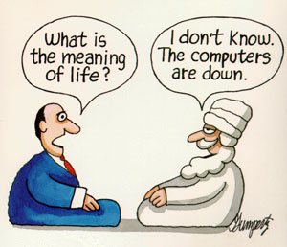
Can the Meaning of Life be found?

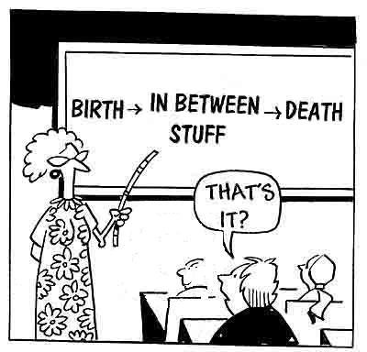

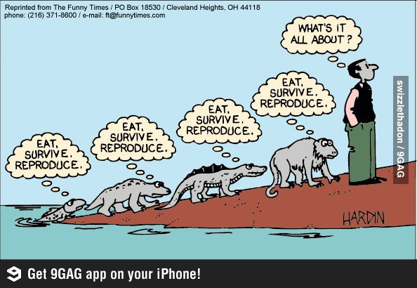

Does the very question suggest that we are different than the animals?

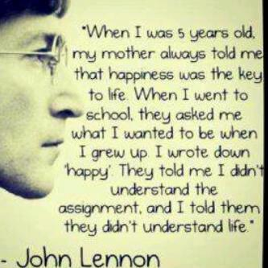

Can we even find one answer to the question? Is this sufficient?

“Life has no meaning. Each of us has meaning and we bring it to life. It is a waste to be asking the question when you are the answer.”
― Joseph Campbell

“The purpose of life is to stay alive. Watch any animal in nature--all it tries to do is stay alive. It doesn't care about beliefs or philosophy. Whenever any animal's behavior puts it out of touch with the realities of its existence, it becomes exinct.”
― Michael Crichton, Congo

“Life has to be given a meaning because of the obvious fact that it has no meaning.”
― Henry Miller

Challenges are what make life interesting; overcoming them is what makes life meaningful.
― Joshua J. Marine

“We think we can make honey without sharing in the fate of bees, but we are in truth nothing but poor bees, destined to accomplish our task and then die.”
― Muriel Barbery, The Elegance of the Hedgehog

“The human race is a monotonous affair. Most people spend the greatest part of their time working in order to live, and what little freedom remains so fills them with fear that they seek out any and every means to be rid of it.”
― Johann Wolfgang von Goethe, The Sorrows of Young Werther

“Energy is the basis of everything. Every Jew, no matter how insignificant, is engaged in some decisive and immediate pursuit of a goal… It is the most perpetual people of the earth…”
― Johann Wolfgang von Goethe, German dramatist, novelist and poet (1749 - 1832)

בראשית פרק א פסוק כו
וַיֹּאמֶר אֱלֹהִים נַעֲשֶׂה אָדָם בְּצַלְמֵנוּ כִּדְמוּתֵנוּ וְיִרְדּוּ בִדְגַת הַיָּם וּבְעוֹף הַשָּׁמַיִם וּבַבְּהֵמָה וּבְכָל הָאָרֶץ וּבְכָל הָרֶמֶשׂ הָרֹמֵשׂ עַל הָאָרֶץ:
Genesis 1:26
And God said, "Let us make man in our image, after our likeness, and they shall rule over the fish of the sea and over the fowl of the heaven and over the animals and over all the earth and over all the creeping things that creep upon the earth."

בראשית פרק ב
(ג) וַיְבָרֶךְ אֱלֹהִים אֶת יוֹם הַשְּׁבִיעִי וַיְקַדֵּשׁ אֹתוֹ כִּי בוֹ שָׁבַת מִכָּל מְלַאכְתּוֹ אֲשֶׁר בָּרָא אֱלֹהִים לַעֲשׂוֹת:

Genesis 2:3
And God blessed the seventh day and He hallowed it, for thereon He abstained from all His work that God created to do.

קהלת פרק יב
(יג) סוֹף דָּבָר הַכֹּל נִשְׁמָע אֶת הָאֱלֹהִים יְרָא וְאֶת מִצְוֹתָיו שְׁמוֹר כִּי זֶה כָּל הָאָדָם:

Ecclesiastes 12:13
The end of the matter, everything having been heard, fear God and keep His commandments, for this is the entire man.

“The entire purpose of our existence is to overcome our negative habits.”
― Vilna Goan, Commentary to Mishlei 4:13

Rabbi Zusha used to say: “When I die and come before the heavenly court, if they ask me, ‘Zusha, why were you not Abraham?’ I’ll say that I didn’t have Abraham’s intellectual abilities. If they say, ‘Why were you not Moses?’ I’ll say I didn’t have Moses’ leadership abilities. For every such question, I’ll have an answer. But if they say, ‘Zusha, why were you not Zusha?’ for that, I’ll have no answer.”
― Rabbi Meshulam Zusha of Hanipol (1718–1800)

“I will insist the Hebrews have [contributed] more to civilize men than any other nation. If I was an atheist and believed in blind eternal fate, I should still believe that fate had ordained the Jews to be the most essential instrument for civilizing the nations ... They are the most glorious nation that ever inhabited this Earth. The Romans and their empire were but a bubble in comparison to the Jews. They have given religion to three-quarters of the globe and have influenced the affairs of mankind more and more happily than any other nation, ancient or modern.”
― John Adams, Second President of the United States

Is the Meaning of Your Life to Make Babies?
What can — and cannot — be learned from evolution
By Lawrence Rifkin | The Scientific American, March 24, 2013

From an evolutionary gene’s-eye perspective, the genes are immortal, and our role, the meaning of life, is to perpetuate the genes. In a few centuries, all traces of our existence as human individuals — memories of us, all our accomplishments –will likely be gone and forgotten, except for genes that survive from those of us who successfully reproduced through the generations.

But, of course, we don’t experience the world from a gene’s eye evolutionary perspective. One experiences the world as an individual person, not as a gene dispenser (fun as that may be). The joy we get from parenting comes not from some abstract generic idea of gene propagation, but from specific love and interaction with our own children — making your own baby son giggle uncontrollably when you make ridiculous animal noises, the bittersweet emotional rush you feel as you watch your daughter walk down the aisle. We care about ourselves and others as persons, not as a gene menagerie. Humans create our own meanings.

But — reproduction as the answer to life’s meaning cannot be dismissed quite so easily. Genetic evolution is the meaning of biologic life, in that it is the why and how of it, as well as the stock of future biological existence. The genes that survive — and in turn the organisms they make — are the winners in the existence game. Can we just dismiss this when considering the meaning of our own individual human lives? Sure, evolution itself does not have a specific direction or teleology, and genes themselves are not conscious, so there is not meaning in that sense. But evolution cannot just be shrugged off as something apart from us, take it or leave it. It is the biological explanation of who we are, how we got here, and the diversity of life. Over billions of years, life left the oceans, stretched limbs to cover the earth, raised wings to fly. Underlying it all are the replicating molecules that continue to copy themselves even now. We owe our existence to this process, and our future depends on it. Perhaps the meaning of your life as a biological creature is to make babies and help ensure the survival of life. In discussing the children she had with Carl Sagan, Ann Druyan put it like this: “When we come closest to each other we can create new life forms that carry on that continuity that stretches back all those billions of years, and in them are the generations of human beings who have struggled. That is magnificent.”

By making babies, we continue life’s pageant. In children, we cheat death.

Yet something seems fundamentally very wrong, or incomplete, with this idea that making babies is the meaning of life. I wouldn’t be jumping with jubilation if my teenage son announced today that he was going to be a father. Do we laud the parents of extremely large Mormon, Hasid, Catholic, and Muslim families as public exemplars of a meaningful life? Do we honor the most popular sperm donor as humankind’s greatest philanthropist?

Even if our genes get perpetuated, our genes are not us. After a few generations of genetic mixing and shuffling, there’s unlikely to be anything unique or identifying about us in our offspring. If your great-great-grandchild has your brown eyes and your blood type, but no other personality or physical traits uniquely identifiable to you, how much of “you” has really lived on? Further, if the idea is to perpetuate our genetic lineage, what if we have children, but no grandchildren?

Fundamentally, as humans, the problem with identifying the meaning of life with having children is this — to link meaningfulness only with child production seems an affront to human dignity, individual differences, and personal choice. Millions of homosexuals throughout the world do not have children biologically. Millions of heterosexual adults are unable to have children biologically. For many adults, not having children is the right choice, for themselves, the world, the economy, or for their would-be children. Socrates, Julius Caesar, Leonardo da Vinci, George Washington, Jane Austen, Florence Nightingale, John Keats, Vincent van Gogh, Vladimir Lenin, and Steven Pinker as far as we know did not have biological children.

Would we deny the meaningfulness of their impact or existence? The meaning of life for childless adults — roughly 20% of the population in the U.S. and U.K. – has nothing to do with fame, but everything to do with what makes life meaningful for everyone: experiencing pleasure, personal relationships, and engagement in positive activities and accomplishments.

From a moral perspective if you are giving of your life for an adopted child, a parent, creative production, teaching, volunteer work, or anything that helps others, adds to happiness, and makes the world a better place — then an evolutionary genetic perspective seems irrelevant. It is from such bedrocks that human meaning springs. Human meanings are worthwhile regardless of long-term, universal, final consequences, because they are meaningful now.

Also, it’s not just the seed alone that produces bountiful produce, it’s the entire garden and all it takes to nurture it. The environment is a critical part of the equation. Evolution by natural selection occurs by differential survival and reproduction of genes in a population as a consequence of interactions with the environment. There is also the danger of overpopulation, which could result in famine, disease, and environmental catastrophe, perhaps jeopardizing the future evolutionary success of the entire species. So, ironically, perhaps not having children is the best way to ensure longevity of the human genome. Unlike other animals, we can be conscious stewards of the future.

So is making babies — and having genes survive through the generations — the meaning of life? The answer is yes — from an evolutionary gene’s eye view. Making babies, and also other actions and social structures that result in the survival and reproduction of one’s gene, such as protecting one’s relatives. Differential reproduction is a process which, in conjunction with environmental interactions, has led to all life as we know it, with all its diversity and grandeur, including conscious experience itself. This is modern knowledge that is not to be taken lightly, and has impact on how we view our own meaning.

But from almost every other perspective — individual, group, moral, environmental, or concern for life as a whole — the answer to the question is no. Meaning from these perspectives — from life as it is actually experienced — is up to us. Reproduction and genetic survival may be the meaning of Life, but it is not inescapably the meaning of your life.

So, in the end, the full answer is no — we do not bestow having babies as the sole guardians of life’s meaning. But we do need to respect and grapple with the view. Differential genetic success, as a result of reproduction and environmental conditions will — for better or worse — provide the template for what humans will become in the future. It is to evolutionary genetic success that we — and all life — owe our existence, and to which the future of all life on Earth depends. Including creatures that create our own meaning. We perform our solos with passion, but we are playing in nature’s grand symphony.

