Faith in a Faithless World

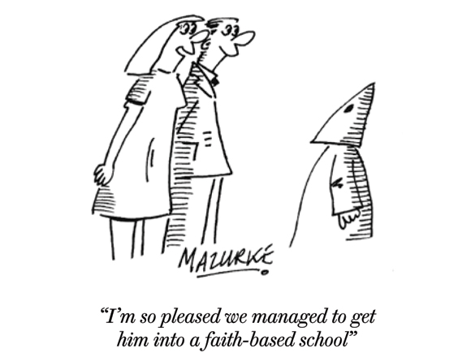
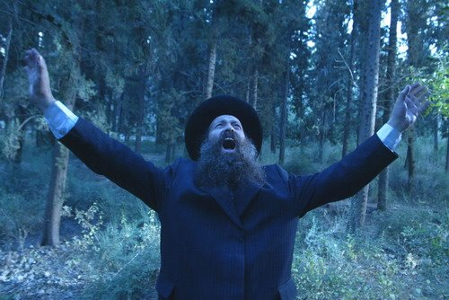

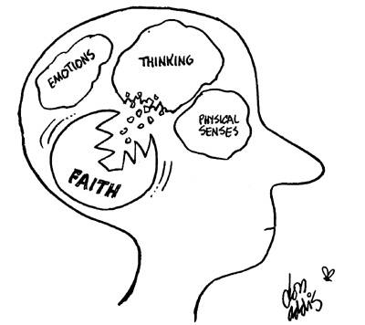
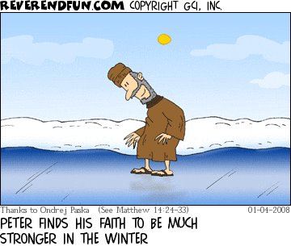

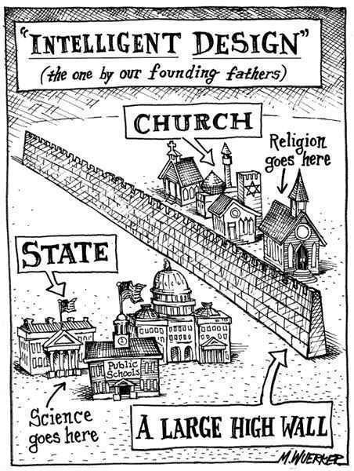
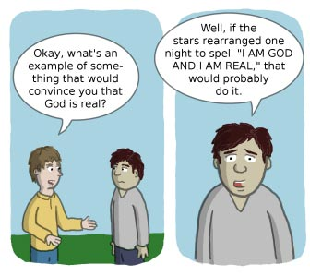
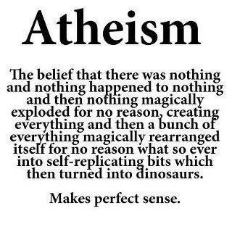
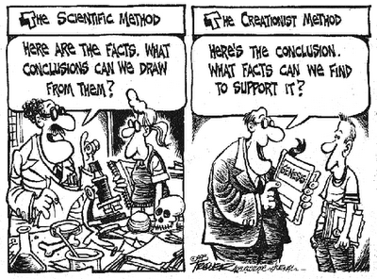
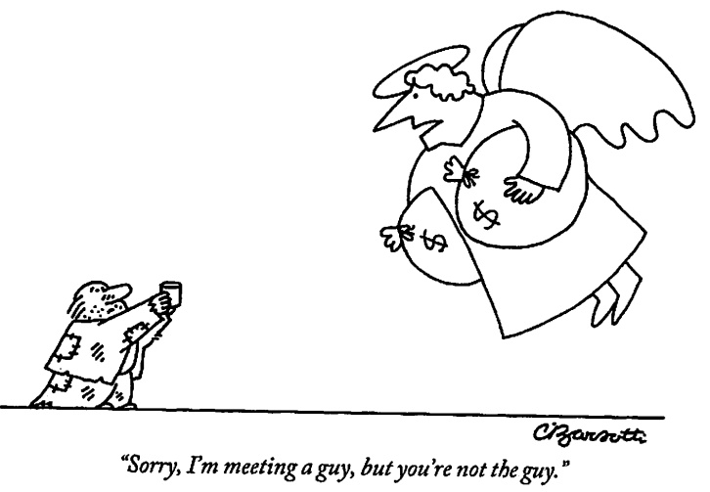
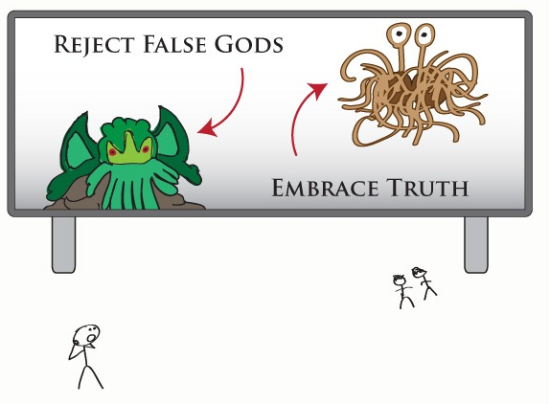
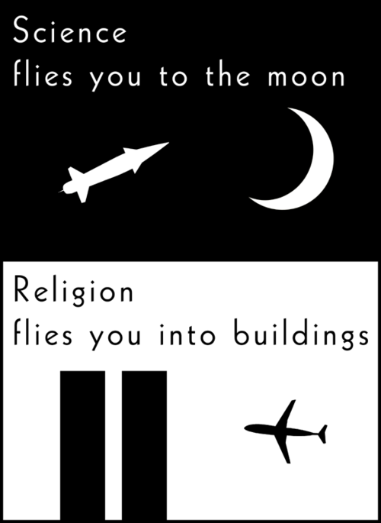
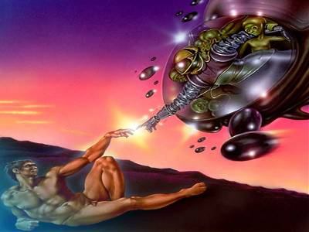

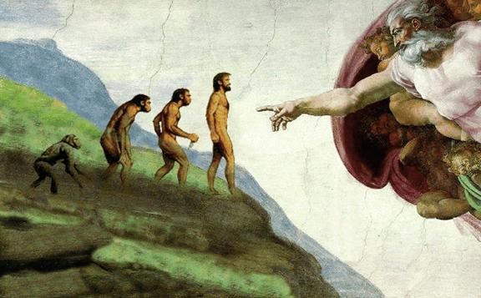

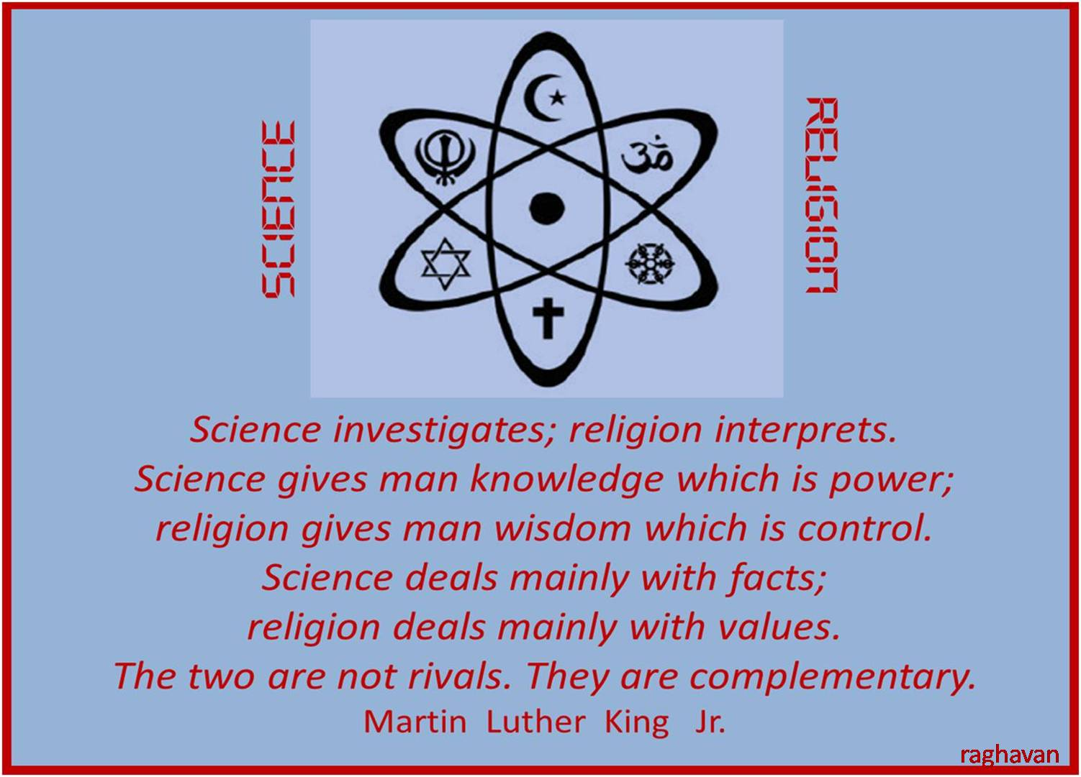

Faith is taking the first step even when you don't see the whole staircase.
Martin Luther King, Jr.

That deep emotional conviction of the presence of a superior reasoning power, which is revealed in the incomprehensible universe, forms my idea of God. Albert Einstein

Faith is to believe what you do not see; the reward of this faith is to see what you believe. Saint Augustine

Now, God be praised, that to believing souls gives light in darkness, comfort in despair. William Shakespeare

We are never defeated unless we give up on God. Ronald Reagan

All I have seen teaches me to trust the Creator for all I have not seen.
Ralph Waldo Emerson

Faith is a knowledge within the heart, beyond the reach of proof. Kahlil Gibran

Faith is the great cop-out, the great excuse to evade the need to think and evaluate evidence. Faith is belief in spite of, even perhaps because of, the lack of evidence. Professor Richard Dawkins

To one who has faith, no explanation is necessary. To one without faith, no explanation is possible. St. Thomas Aquinas

As your faith is strengthened you will find that there is no longer the need to have a sense of control, that things will flow as they will, and that you will flow with them, to your great delight and benefit. Emmanuel Teney

Faith makes the discords of the present the harmonies of the future. Robert Collyer

Faith is not something to grasp, it is a state to grow into. Mohandas Gandhi

A casual stroll through the lunatic asylum shows that faith does not prove anything. Friedrich Nietzsche

בראשית פרק טו
(ה) וַיּוֹצֵא אֹתוֹ הַחוּצָה וַיֹּאמֶר הַבֶּט נָא הַשָּׁמַיְמָה וּסְפֹר הַכּוֹכָבִים אִם תּוּכַל לִסְפֹּר אֹתָם וַיֹּאמֶר לוֹ כֹּה יִהְיֶה זַרְעֶךָ: (ו) וְהֶאֱמִן בַּיקֹוָק וַיַּחְשְׁבֶהָ לּוֹ צְדָקָה:
Genesis 15:5-6
5. And He took him outside, and He said, "Please look heavenward and count the stars, if you are able to count them." And He said to him, "So will be your seed." 6. And he believed in the Lord, and He accounted it to him as righteousness.

שמות פרק יד
(ל) וַיּוֹשַׁע יְקֹוָק בַּיּוֹם הַהוּא אֶת יִשְׂרָאֵל מִיַּד מִצְרָיִם וַיַּרְא יִשְׂרָאֵל אֶת מִצְרַיִם מֵת עַל שְׂפַת הַיָּם: (לא) וַיַּרְא יִשְׂרָאֵל אֶת הַיָּד הַגְּדֹלָה אֲשֶׁר עָשָׂה יְקֹוָק בְּמִצְרַיִם וַיִּירְאוּ הָעָם אֶת יְקֹוָק וַיַּאֲמִינוּ בַּיקֹוָק וּבְמֹשֶׁה עַבְדּוֹ:
Exodus 14:30-31
30. On that day the Lord saved Israel from the hand[s] of the Egyptians, and Israel saw the Egyptians dying on the seashore. 31. And Israel saw the great hand, which the Lord had used upon the Egyptians, and the people feared the Lord, and they believed in the Lord and in Moses, His servant.

Rabbi Moshe ben Maimon (Maimonides, d. 1204) Moreh Nevuchim 3:51
One should not believe something to be true unless it belongs to one of three categories. 1. Something that can be validated by clear proof based upon human reasoning or empirically e.g., arithmetic, geometry or astronomy. 2. Something that can be perceived directly by one of the five senses. For example if he sees something is red or black, or he tastes something is bitter or sweet or he can feel that something is hot or cold... 3. Something which he has received as a tradition from the prophets and righteous people. A sensible person needs to classify everything he believes into that which is based on rational proof, that which he directly perceives with his senses and that which he believes because of valid tradition. Anyone who believes something outside of these three categories is described by the verse (Proverbs 14:15), ‘A fool believes in everything.’

הושע פרק ב פסוק כא
וְאֵרַשְׂתִּיךְ לִי לְעוֹלָם וְאֵרַשְׂתִּיךְ לִי בְּצֶדֶק וּבְמִשְׁפָּט וּבְחֶסֶד וּבְרַחֲמִים:
Hosea 2:21
And I will betroth you to Me forever, and I will betroth you to Me with righteousness and with justice and with loving-kindness and with mercy.

מלבי"ם לספר הושע פרק ב פסוק כא - חלק באור המלים
חסד רחמים - עי' מ"ש ישעיה ס"ג ו', באמונה, וידעת הידיעה הוא בדבר שהשיג בחושיו או שהתברר לו ע"י מושכל ראשונות עד שא"א שיסופק כלל. והאמונה הוא בדבר שלא השיג בבירור רק שקבל מפי מגידי אמת, ומאמין בדבר, וכ"מ שיש לו ידיעה ברורה א"צ עוד לאמונה:
Malbim (d. 1879) commentary to Hosea 2:21
Knowledge is something which is perceived directly with the senses or is understood through such a clear proof that it is impossible to doubt it at all. Emunah on the other hand is something which is not comprehended in an irrefutable manner but is accepted from highly reliable sources and is believed based on their say so.

