Drugs and Alcohol

Drugs

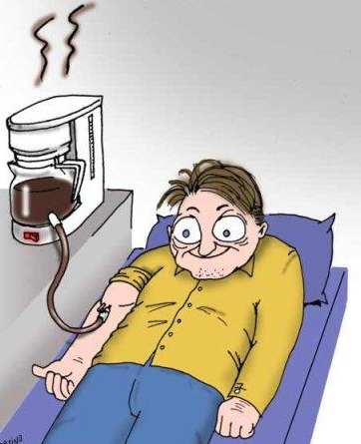
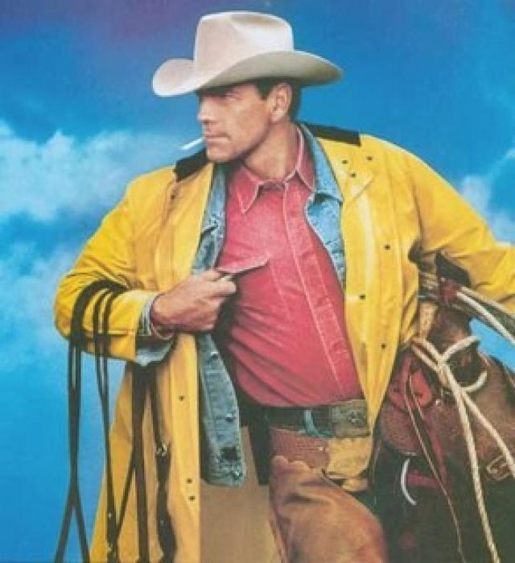
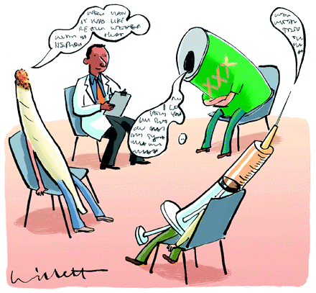

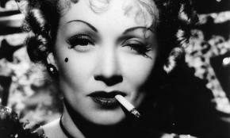
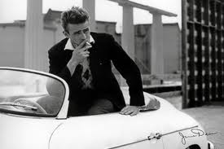

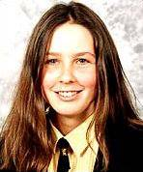
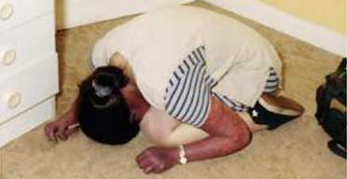

(L) May 2000, Rachel Whitear’s body on the floor of her bedsit in Exmouth. (R) In a school picture.
“I have absolutely no pleasure in the stimulants in which I sometimes so madly indulge. It has not been in the pursuit of pleasure that I have periled life and reputation and reason. It has been the desperate attempt to escape from torturing memories, from a sense of insupportable loneliness and a dread of some strange impending doom.” ― Edgar Allan Poe

“Reality is just a crutch for people who can't handle drugs.” ― Robin P. Williams

“Drugs are a waste of time. They destroy your memory and your self-respect and everything that goes along with your self esteem.” ― Kurt Cobain

“Even as a junkie I stayed true [to vegetarianism] - 'I shall have heroin, but I shan't have a hamburger.' What a sexy little paradox.” ― Russell Brand, My Booky Wook

“Whether you sniff it smoke it eat it or shove it up your ass the result is the same: addiction.” ― William S. Burroughs

“A drug is not bad. A drug is a chemical compound. The problem comes in when people who take drugs treat them like a license to behave like an asshole.” ― Frank Zappa, The Real Frank Zappa Book

“Selling my soul would be a lot easier if I could just find it.”
― Nikki Sixx, The Heroin Diaries: A Year In The Life Of A Shattered Rock Star

“You realize that people take drugs because it's the only real personal adventure left to them in their time-constrained, law-and-order, property-lined world. It's only in drugs or death we'll see anything new, and death is just too controlling.” ― Chuck Palahniuk, Survivor

“Drugs are a bet with your mind.” ― Jim Morrison

“Some of us look for the Way in opium and some in God, some of us in whiskey and some in love. It is all the same Way and it leads nowhither.”
― W. Somerset Maugham, The Painted Veil

“Drug misuse is not a disease, it is a decision, like the decision to step out in front of a moving car. You would call that not a disease but an error of judgment.” ― Philip K. Dick

“So, now I've been to see a drug counselor who told me I need to lay off the drugs and talk about my feelings, and a shrink who heard what I had to say and immediately put me on drugs.” ― Libba Bray, Going Bovine

Alcohol
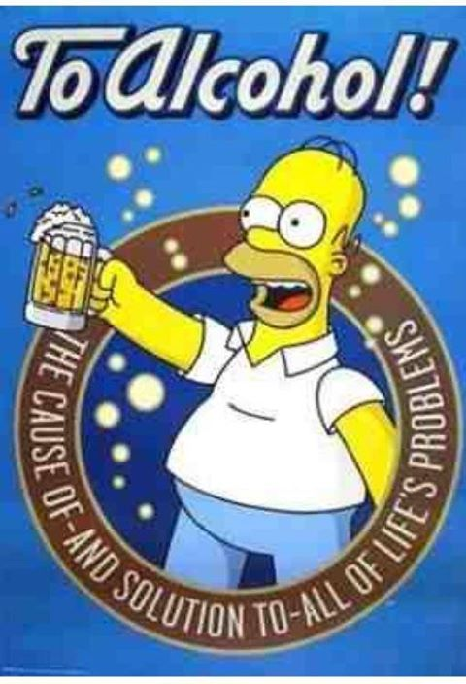
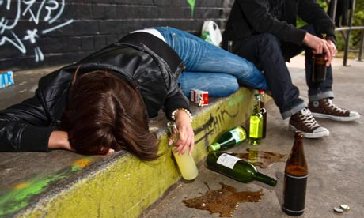

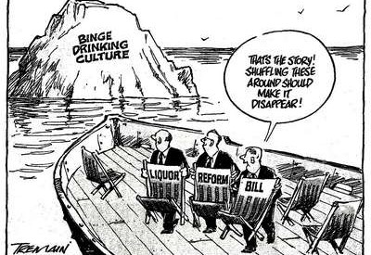

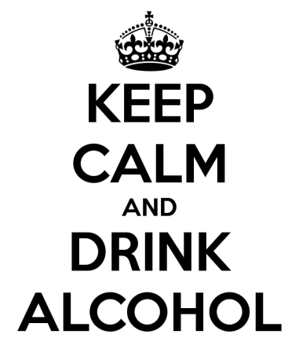
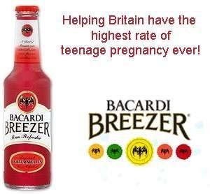
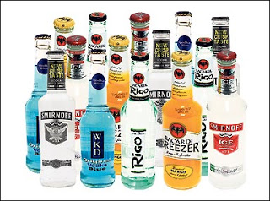
“[I]t is the wine that leads me on, the wild wine that sets the wisest man to sing at the top of his lungs, laugh like a fool – it drives the man to dancing... it even tempts him to blurt out stories better never told.” ― Homer, The Odyssey

“That's the problem with drinking, I thought, as I poured myself a drink. If something bad happens you drink in an attempt to forget; if something good happens you drink in order to celebrate; and if nothing happens you drink to make something happen.” ― Charles Bukowski, Women

“Only Irish coffee provides in a single glass all four essential food groups: alcohol, caffeine, sugar and fat.”
― Alex Levin

“Alcohol ruined me financially and morally, broke my heart and the hearts of too many others. Even though it did this to me and it almost killed me and I haven't touched a drop of it in seventeen years, sometimes I wonder if I could get away with drinking some now. I totally subscribe to the notion that alcoholism is a mental illness because thinking like that is clearly insane.”
― Craig Ferguson, American on Purpose: The Improbable Adventures of an Unlikely Patriot

“Ignorance is a lot like alcohol: the more you have of it, the less you are able to see its effect on you.”
― Jay M. Bylsma

MACDUFF What three things does drink especially provoke?
PORTER Marry, sir, nose-painting, sleep, and urine. Lechery, sir, it provokes, and unprovokes; it provokes the desire, but it takes away the performance: therefore, much drink may be said to be an equivocator with lechery: it makes him, and it mars him; it sets him on, and it takes him off; it persuades him, and disheartens him; makes him stand to, and not stand to; in conclusion, equivocates him in a sleep, and, giving him the lie, leaves him.
― William Shakespeare, Macbeth

תלמוד בבלי מסכת פסחים דף קיג עמוד א
אמר ליה רב לחייא בריה: לא תשתי סמא.
Babylonian Talmud Tractate Pesachim 113a
Rav Chiya said to his son: ‘Do not take [lit. drink] drugs.

רשב"ם מסכת פסחים דף קיג עמוד א
לא תשתי סמא. אל תשתה סמים מפני שנקבע להם ווסת ויהא לבך שואלך ותפסיד מעות ואפילו לרפואה לא תישתי אם אפשר לרפואה אחרת:
Rashbam (d. 1158) on Pesachim 113a
Don’t take drugs – don’t take drugs because you will become addicted to them and your heart will want them and you will lose all of your money. Even for healing purposes, do not take them if it is possible to find an alternative remedy.

ויקרא פרק י
(ח) וַיְדַבֵּר יְקֹוָק אֶל אַהֲרֹן לֵאמֹר: (ט) יַיִן וְשֵׁכָר אַל תֵּשְׁתְּ אַתָּה וּבָנֶיךָ אִתָּךְ בְּבֹאֲכֶם אֶל אֹהֶל מוֹעֵד וְלֹא תָמֻתוּ חֻקַּת עוֹלָם לְדֹרֹתֵיכֶם: (י) וּלֲהַבְדִּיל בֵּין הַקֹּדֶשׁ וּבֵין הַחֹל וּבֵין הַטָּמֵא וּבֵין הַטָּהוֹר: (יא) וּלְהוֹרֹת אֶת בְּנֵי יִשְׂרָאֵל אֵת כָּל הַחֻקִּים אֲשֶׁר דִּבֶּר יְקֹוָק אֲלֵיהֶם בְּיַד מֹשֶׁה:
Leviticus 10:8-11
8. And the Lord spoke to Aaron, saying. 9. Do not drink wine that will lead to intoxication, neither you nor your sons with you when you go into the Tent of Meeting, so that you shall not die. [This is] an eternal statute for your generations, 10. to distinguish between holy and profane and between unclean and clean, 11. and to instruct the children of Israel regarding all the statutes which the Lord has spoken to them through Moses.

משלי פרק כג פסוק ל
לַמְאַחֲרִים עַל הַיָּיִן לַבָּאִים לַחְקֹר מִמְסָךְ:
Proverbs 23:30
30. Those who sit late over wine, those who come to search for mixed wine.

משלי פרק כ פסוק א
לֵץ הַיַּין הֹמֶה שֵׁכָר וְכָל שֹׁגֶה בּוֹ לֹא יֶחְכָּם:
Proverbs 20:1
1. The [imbiber of] wine is a scorner; he roars, "Strong drink!" And whoever strays with it will not become wise.

משלי פרק כא פסוק יז
אִישׁ מַחְסוֹר אֹהֵב שִׂמְחָה אֹהֵב יַיִן וָשֶׁמֶן לֹא יַעֲשִׁיר:
Proverbs 21:17
17. He who loves joy shall be a poor man; he who loves wine and oil shall not become rich.

משלי פרק לא
(ד) אַל לַמְלָכִים לְמוֹאֵל אַל לַמְלָכִים שְׁתוֹ יָיִן וּלְרוֹזְנִים או אֵי שֵׁכָר: (ה) פֶּן יִשְׁתֶּה וְיִשְׁכַּח מְחֻקָּק וִישַׁנֶּה דִּין כָּל בְּנֵי עֹנִי:
Proverbs 31:4-5
4. It is not for kings, Lemoel, it is not for kings to drink wine, neither is strong drink for rulers. 5 Lest he drink and forget what was made law, and change the judgment of all the impoverished.

תלמוד בבלי מסכת עירובין דף סה עמוד א
נכנס יין יצא סוד.
Babylonian Talmud Tractate Eiruvin 65a
The wine goes in and the secrets come out (in vino vritas).

שולחן ערוך אורח חיים סימן תרצה סעיף ב
חייב אינש לבסומי בפוריא עד דלא ידע בין ארור המן לברוך מרדכי. הגה: וי"א דא"צ להשתכר כל כך, אלא שישתה יותר מלימודו (כל בו) וישן, ומתוך שישן אינו יודע בין ארור המן לברוך מרדכי. (מהרי"ל). ואחד המרבה ואחד הממעיט, ובלבד שיכוין לבו לשמים.
Shulchan Aruch Orach Chaim 695:2
2 A person is obliged to become intoxicated on Purim, to the extent that he will not be aware of the difference between, “Cursed be Haman”, and, “Blessed be Mordechai (Mordecai)”. Gloss: There are authorities who say that one does not need to become as drunk as that, but he should just drink more than he is used to drink and sleep, and being asleep he will not be aware of the difference between “Cursed be Haman”, and, “Blessed be Mordechai”. Whether one drinks more or whether one drinks less it is commendable, provided that his heart’s intention is the service of Heaven.

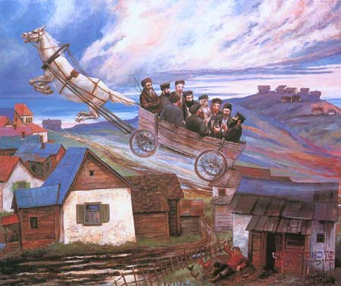

Chassidim traveling to their Rebbe: Painting by Chassidic artist Zalman Kleinman

